Aim:

7a) Configuration of HyperV on Windows of VMs

To configure Hyper-V on Windows for creating and managing virtual

machines (VMs), enabling efficient virtualization and resource utilization.

Steps:

- Open the windows server and open the server manager Click add roles and features . Read before you begin and click next.
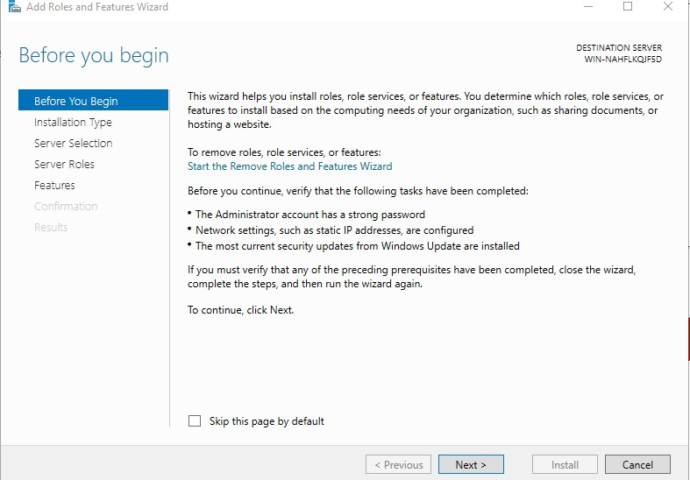
- Select role based installation type and click next.
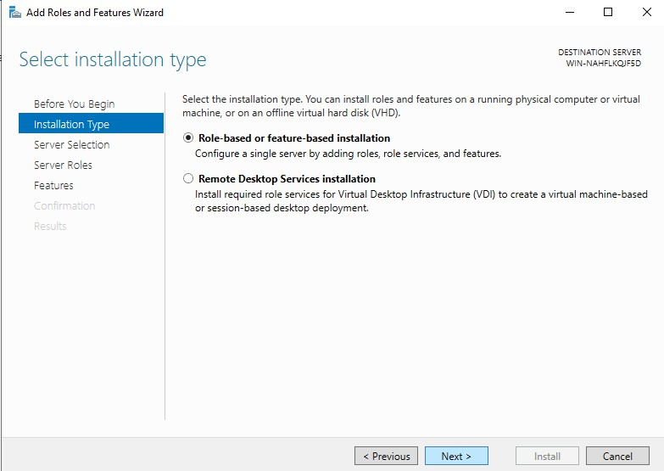

- Select the server and click next
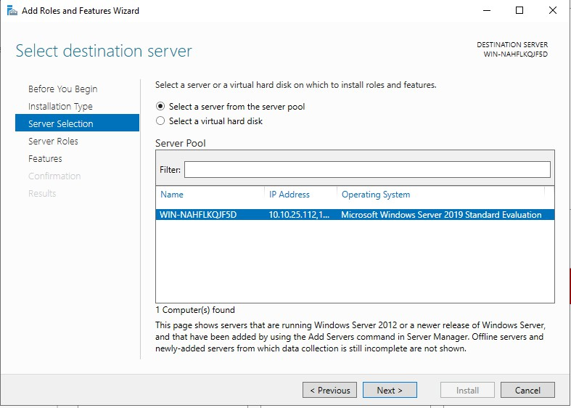

- In server roles .check on hyper v and click the add features .
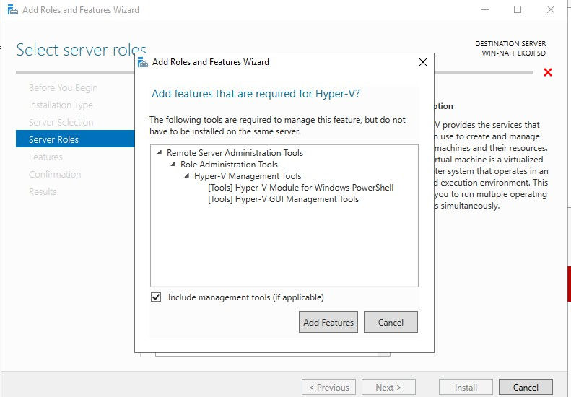

- Enable virtual switches both ethernet and virtual box host only adapter
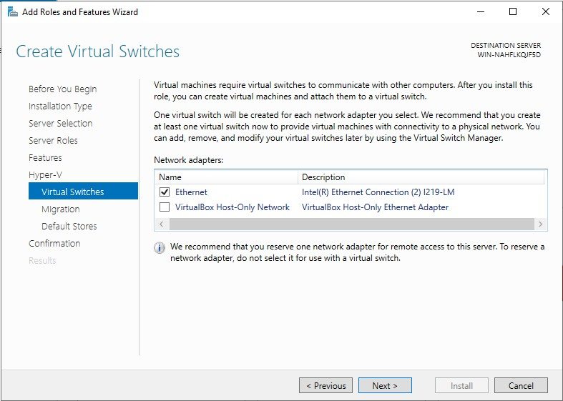

- For migration use credential security support provider
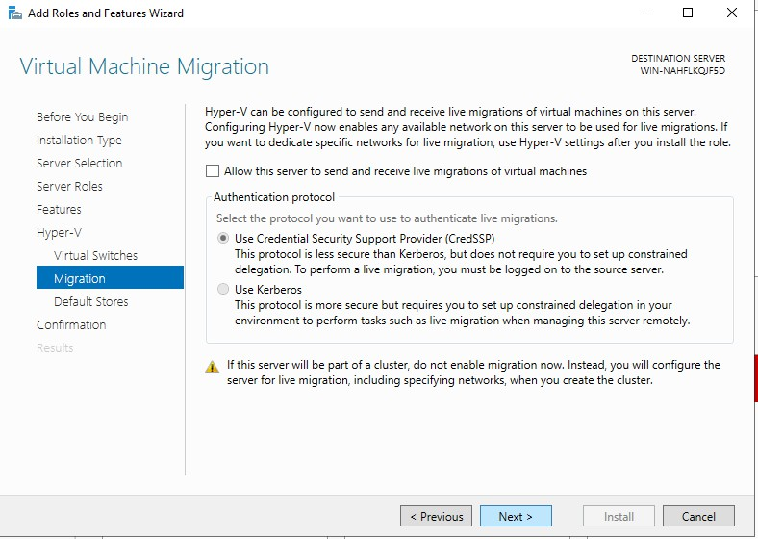

- Click install and hyperv has been installed and enabled on the windows server
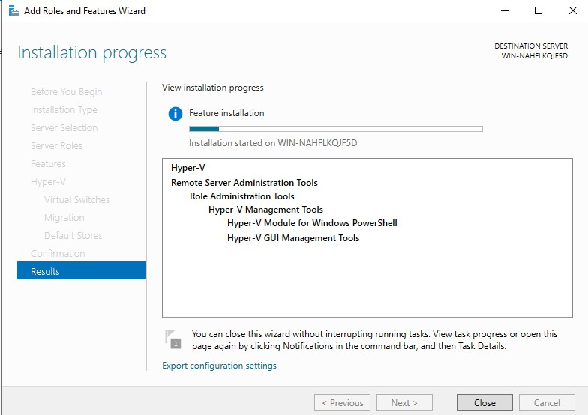

- Open hyperv manager in tools
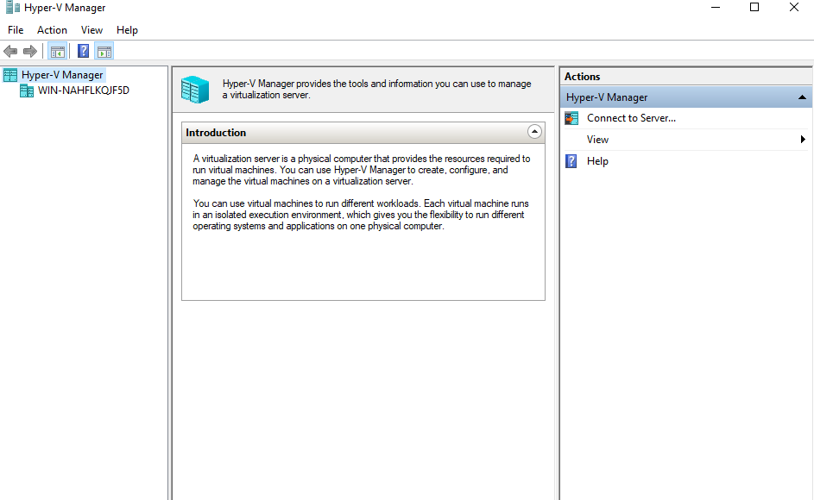

RESULT:

Thus theconfiguration Hyper-V on Windows for creating and managing virtual machines (VMs), enabling efficient virtualization and resource utilization has been executed successfully.

7b) Creation of VM, Powershell commands, Management

Aim:

To create and manage Virtual Machines (VMs) using Hyper-V, including PowerShell commands for automation and efficient administration.
Procedure:

(Vm installation without powershell)

- open Tools-> hyper v manager-> right click on server and click create new vm
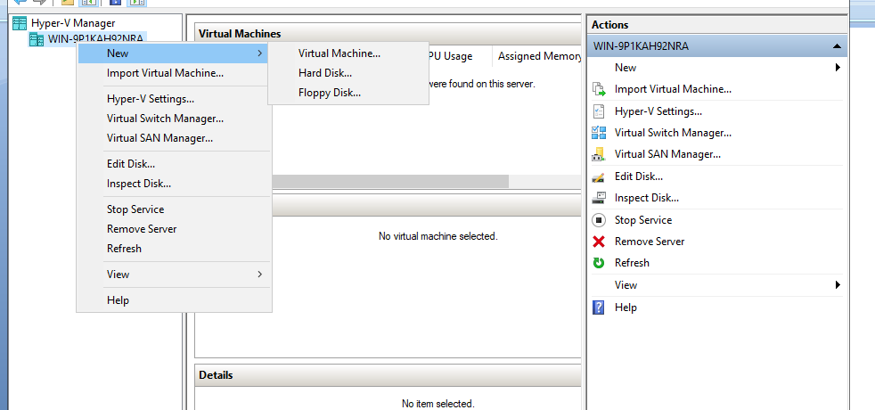
- Specify name and location click next.
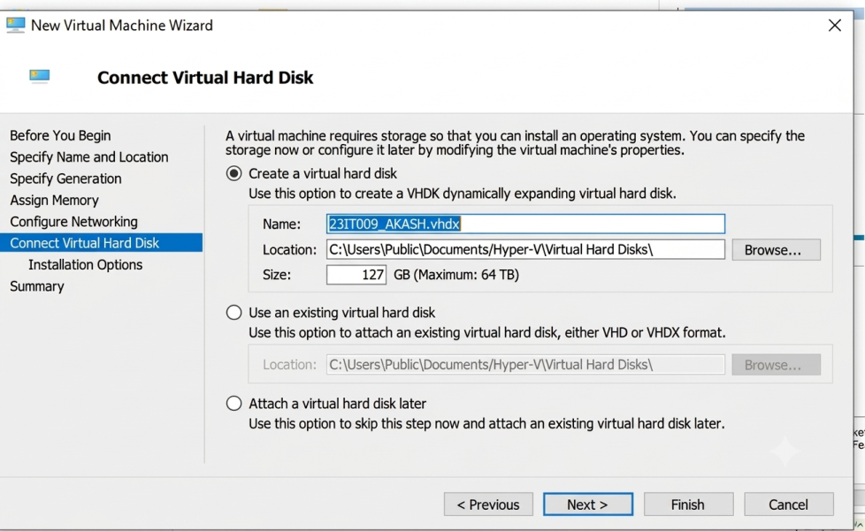

- Assign the memory for the vm(for safety give as 2gb )
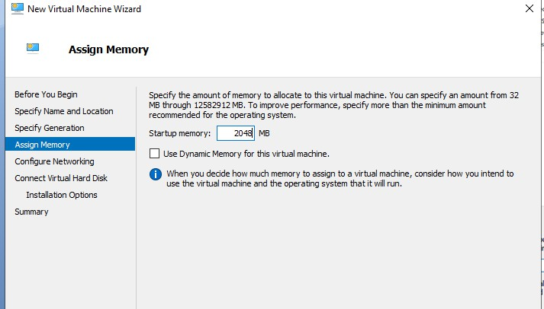
- Conigure the network click on interR Ethernet connection virtual switch
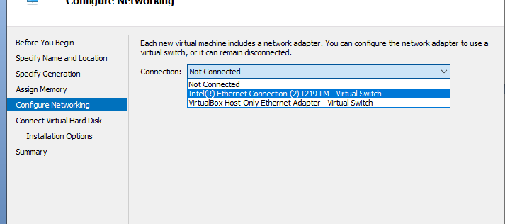
- Connect virtual harddisk (name,location,maximum gb) click next
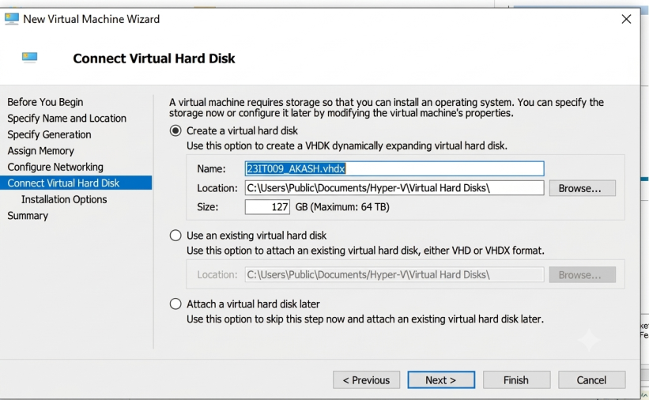
- Import the iso file which os need to install on the vm(here ubunttu)

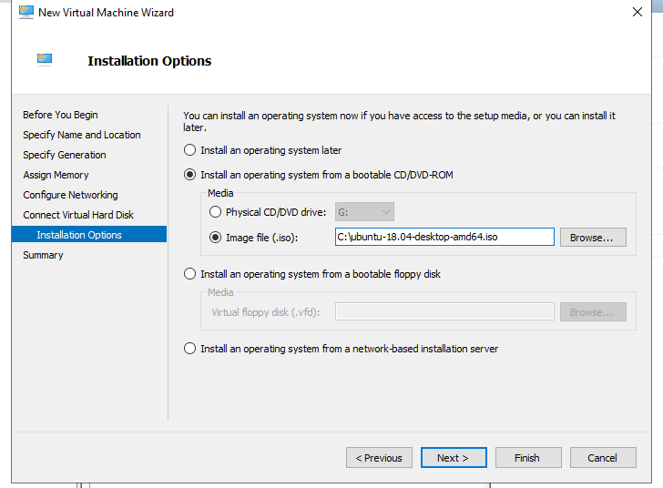
- Click finish
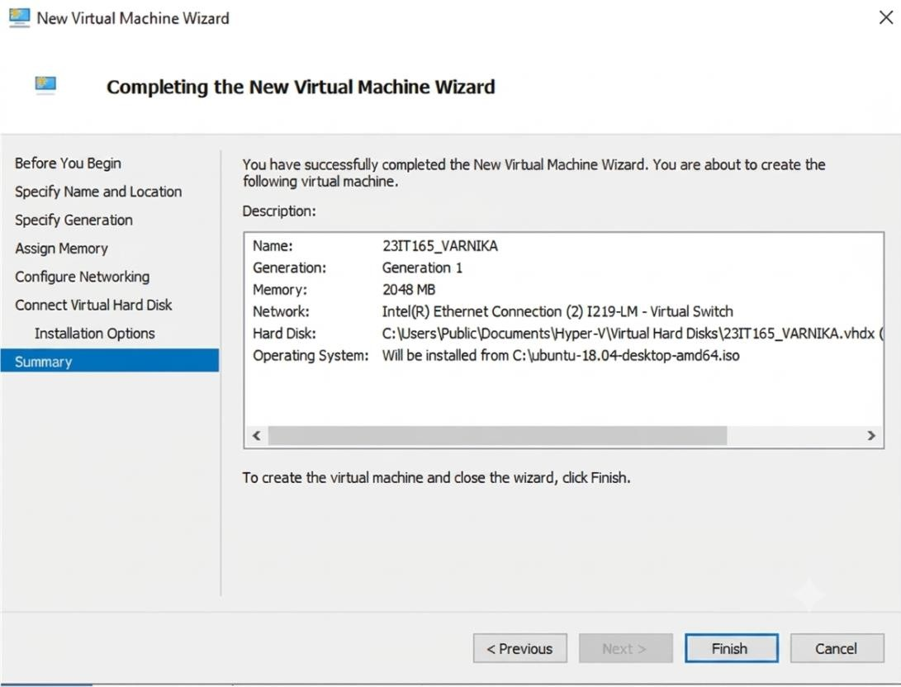
Vm installation using PowershellProcedure :

  - Create vm with name and space in gb with virtual hard disk creation

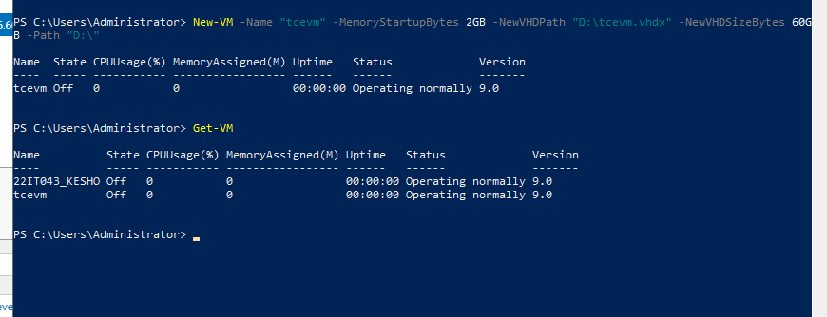

  - Asssign virtual switch to the vm
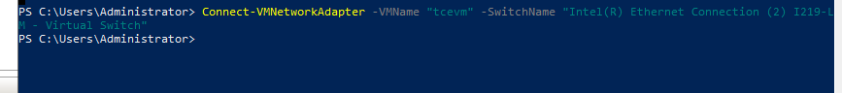

  - import the iso file which os need to install on vm
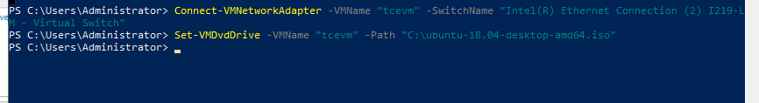

  - Start the vm
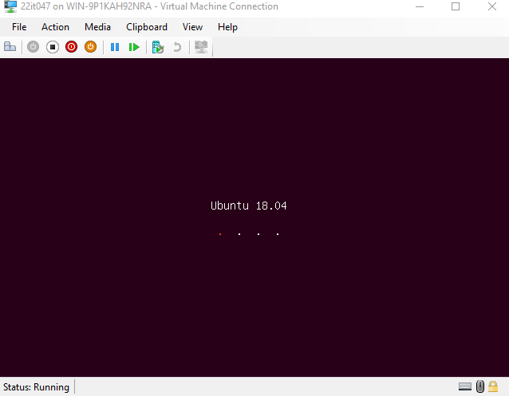

Powershell commands

- Get vm and start vm

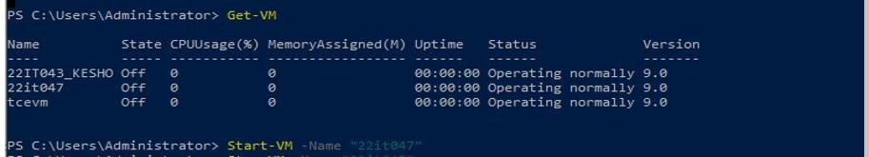

Stop vm
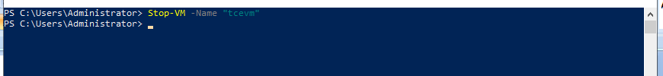

Migration(Right click the vm and click move) and give finish .
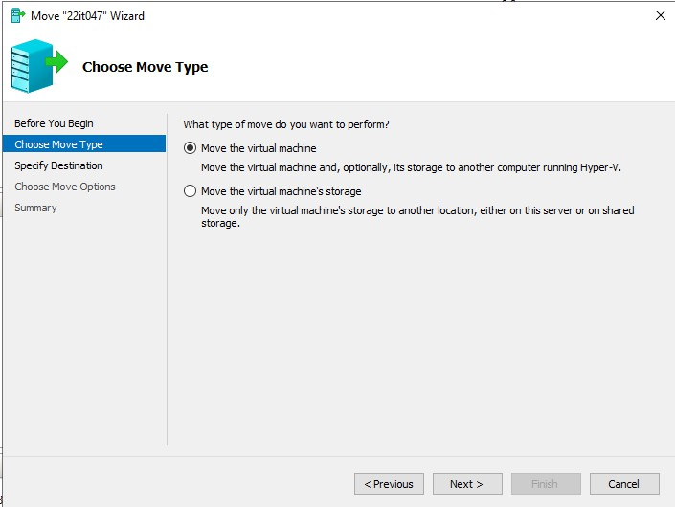

Result:

Thus the creation and manage Virtual Machines (VMs) using Hyper-V, including PowerShell commands for automation and efficient administration has been executed successfully.

